**HEART DISEASE PREDICTION :**

**Problem statement :**

Now a days we are seeing many people are suffering from different diseases among those heart disease is one of the majorly focusing disease if we know earlier we can take the precautions so I’m come of with this heart disease problem

**Goal:**

The goal is to finding out whether the person having heart disease or not with the help of various fields. This helps to get to know the heart disease and take the precautions accordingly.

**DATASET :**

Kaggle dataset path: <https://www.kaggle.com/code/deepmalviya7/heart-disease-prediction-using-random-forest-80/data>

**Visual representation of data :**

Primary hist map:

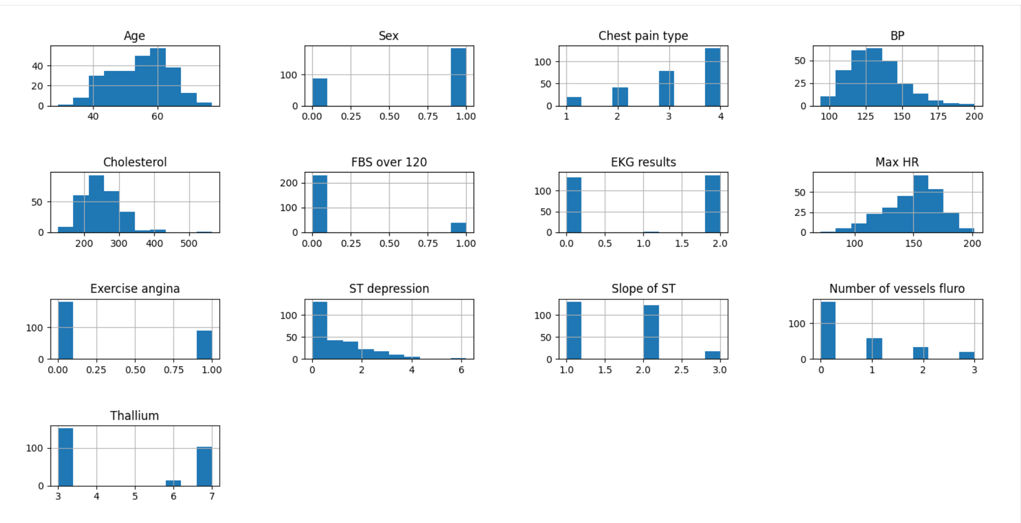

**REPRESENTATION OF PRESENCE DISEASE VS ABSEANCE:**

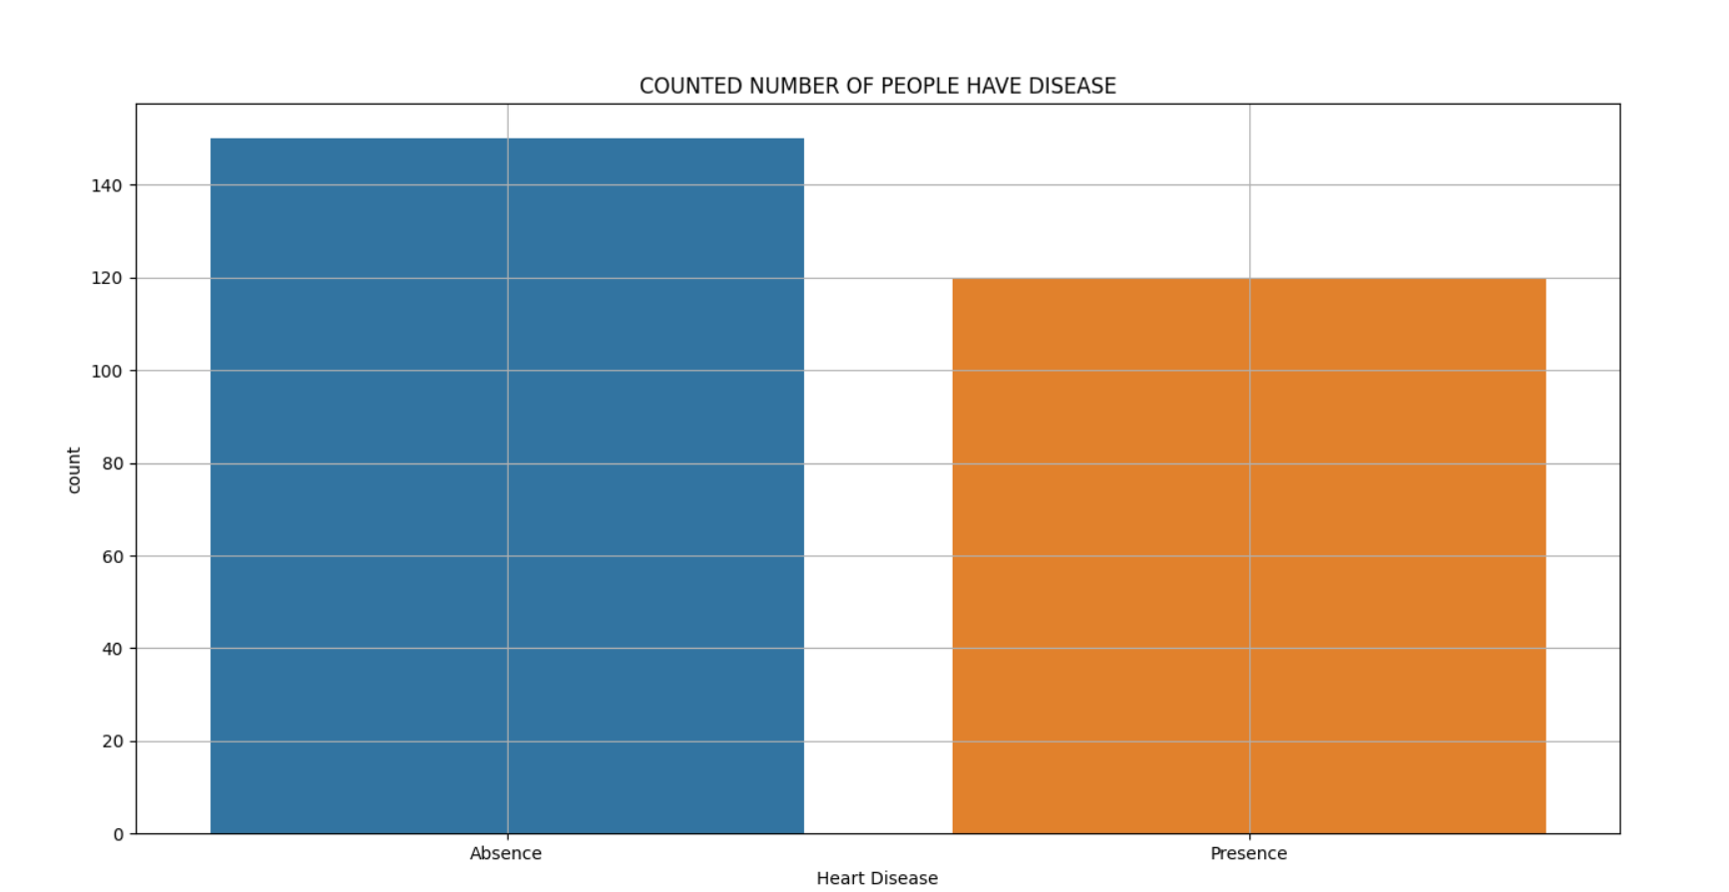

**ALL THE COLUMNS :**

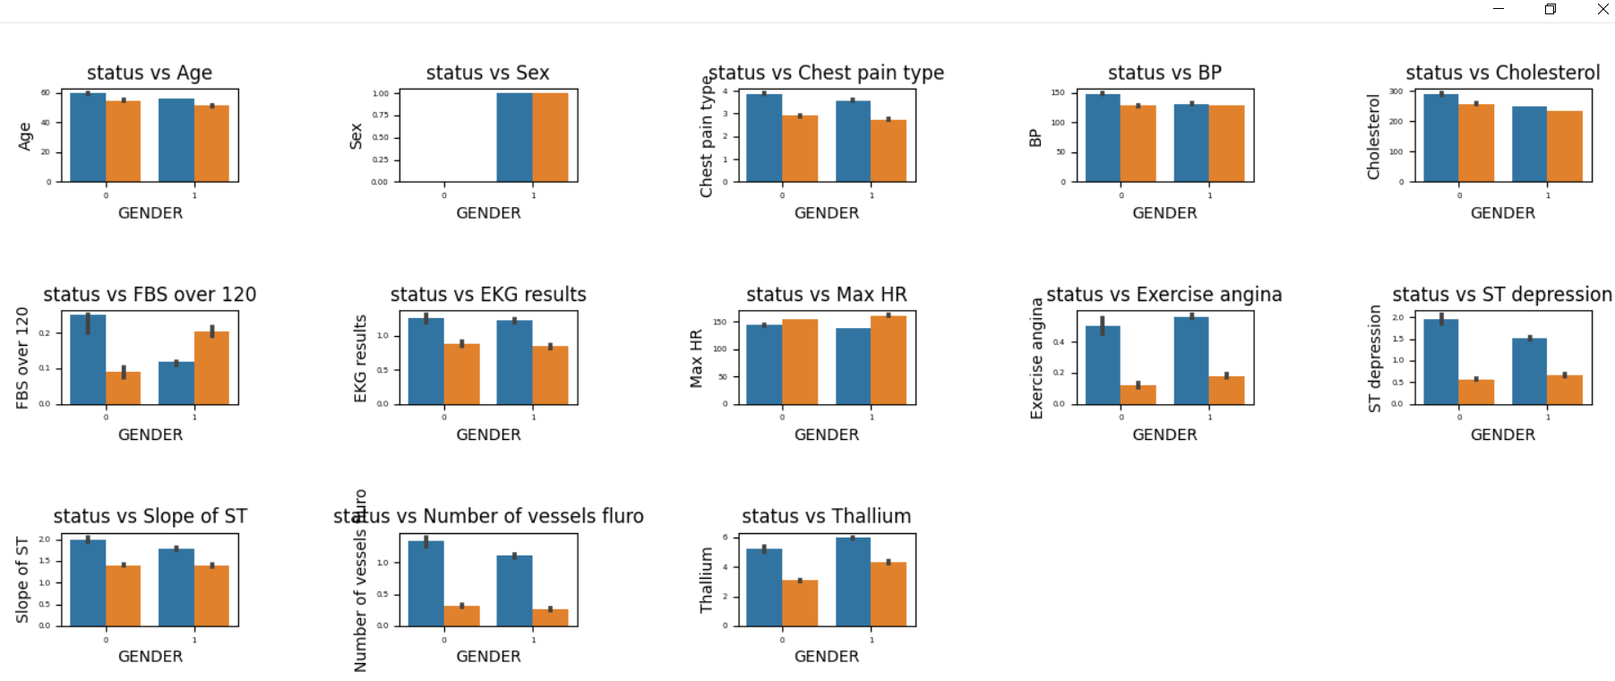

**Correlation b/w variables:**

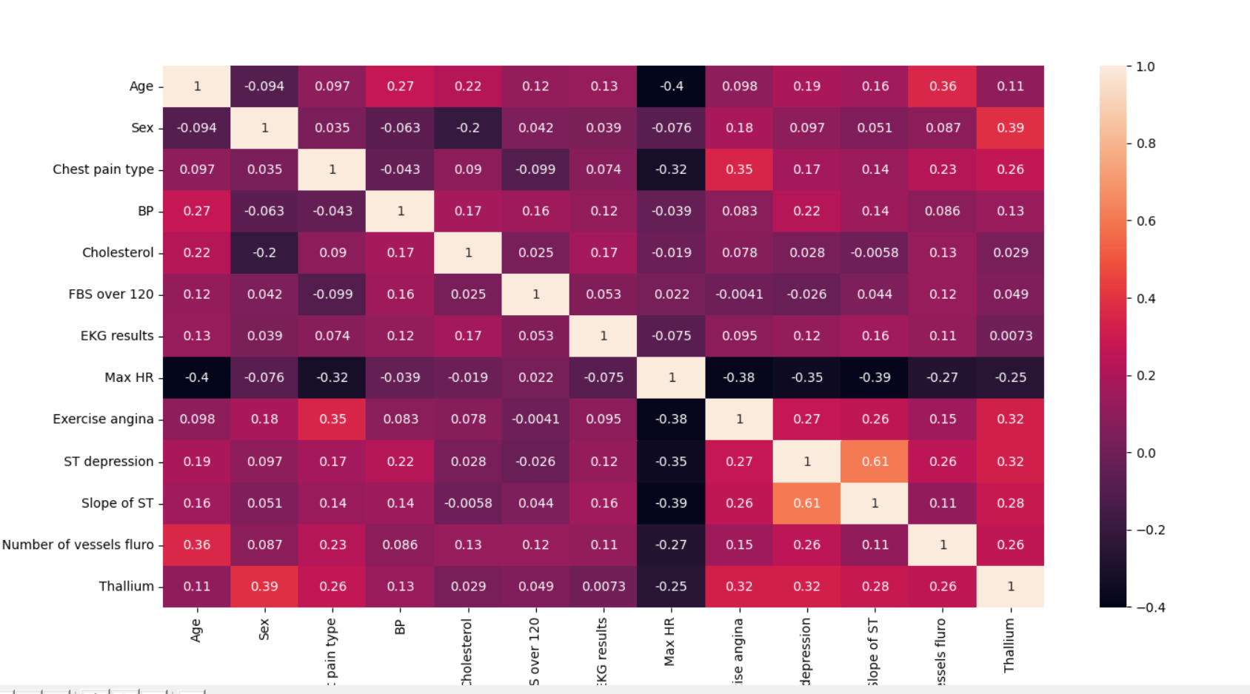

* Normalize the data using standard distribution

**Model selection :**

**Comparison between classification models:**

**Accuracy :**

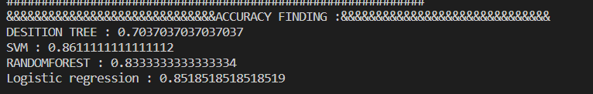

**Cross validation result :**

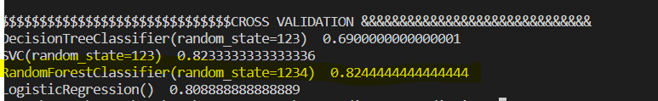

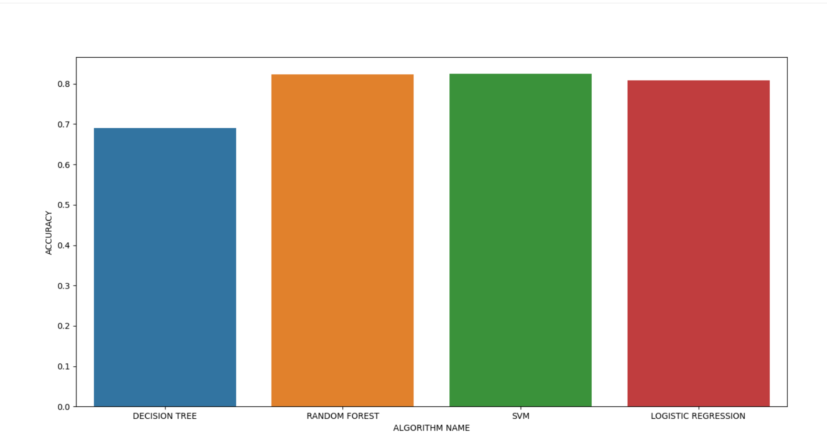

**Reports :**

**Confusion matrix :**

